实验（8）—— 继承

学生姓名：黄伟杰 专业班级：计算机211
课程名称：面向对象程序设计 实验类型：综合

一 实验目的
练习C++继承。

二 实验环境
PC机 + Windows 10操作系统 + CodeBlocks 集成开发环境

三 实验内容
分别实现书本类Book、儿童图书类ChildBook和教科书类TeachBook。书本类中包含书名、出版社、价格等属性及相关的成员函数；儿童图书类由书本类派生，新增适用的儿童年龄段信息及相关的成员函数；教科书类也由书本类派生，新增适用年级和类别信息及相关的成员函数。最后在main中分别测试这三个类。
#include <iostream>
#include <string>
using namespace std;
class Book {
public:
Book(char *_name, char *_pub, char *_price) {
name = _name;
pub = _pub;
price = _price;
}
void Disp() {
cout << ">> 书本类" << '\n';
cout << "书名: " << name << '\n';
cout << "出版社: " << pub << '\n';
cout << "价格: " << price << '\n' << '\n';
}
string name, pub, price;
};
class ChildBook : public Book {
public:
ChildBook(char *_name, char *_pub, char *_price, char *_age) : Book(_name, _pub, _price) {
age = _age;
}
void Disp() {
cout << ">> 儿童图书类" << '\n';
cout << "书名: " << name << '\n';
cout << "出版社: " << pub << '\n';
cout << "价格: " << price << '\n';
cout << "设用年龄: " << age << '\n' << '\n';
}
string age;
};
class TeachBook : public Book {
public:
TeachBook(char *_name, char *_pub, char *_price, char *_age, char *_type) : Book(_name, _pub, _price) {
age = _age;
type = _type;
}
void Disp() {
cout << ">> 教科书类" << '\n';
cout << "书名: " << name << '\n';
cout << "出版社: " << pub << '\n';
cout << "价格: " << price << '\n';
cout << "设用年龄: " << age << '\n';
cout << "类别: " << type << '\n' << '\n';
}
string age, type;
};
int main() {
char t1_name[20] = "一本书", t1_pub[20] = "一个出版社", t1_price[20] = "一个价格";
Book t1(t1_name, t1_pub, t1_price);
t1.Disp();
char t2_name[20] = "一本儿童图书", t2_pub[20] = "一个儿童图书出版社", t2_price[20] = "一个儿童图书价格", t2_age[20] = "一个儿童图书年龄";
ChildBook t2(t2_name, t2_pub, t2_price, t2_age);
t2.Disp();
char t3_name[20] = "一本教科书", t3_pub[20] = "一个教科书出版社", t3_price[20] = "一个教科书价格", t3_age[20] = "一个教科书年龄", t3_type[20] = "教科书";
TeachBook t3(t3_name, t3_pub, t3_price, t3_age, t3_type);
t3.Disp();
return 0;
}
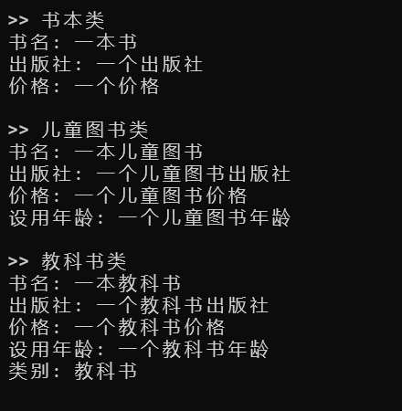
分别实现学生类Student、大学生类StuCollege和浙江农林大学StuZAFU的学生类。学生类中包含姓名、年龄、籍贯、电话等属性及相关的成员函数；大学生类从学生类继承，再加入学院、专业、寝室地址、年级等属性及相关的成员函数；浙江农林大学的学生类则从大学生类继承，再加入校区等属性及相关的成员函数。最后在main中分别测试这三个类。
#include <iostream>
#include <string>
using namespace std;
class Student {
public:
Student(char *_name, char *_age, char *_from, char *_tel) {
name = _name;
age = _age;
from = _from;
tel = _tel;
}
void Disp() {
cout << ">> 学生类" << '\n';
cout << "姓名: " << name << '\n';
cout << "年龄: " << age << '\n';
cout << "籍贯: " << from << '\n';
cout << "电话: " << tel << '\n' << '\n';
}
string name, age, from, tel;
};
class StuCollege : public Student {
public:
StuCollege(char *_name, char *_age, char *_from, char *_tel, char *_acd, char *_mjr, char *_dom, char *_grd) : Student(_name, _age, _from, _tel) {
acd = _acd;
mjr = _mjr;
dom = _dom;
grd = _grd;
}
void Disp() {
cout << ">> 大学生类" << '\n';
cout << "姓名: " << name << '\n';
cout << "年龄: " << age << '\n';
cout << "籍贯: " << from << '\n';
cout << "学院: " << acd << '\n';
cout << "专业: " << mjr << '\n';
cout << "寝室: " << dom << '\n';
cout << "年级: " << grd << '\n' << '\n';
}
string acd, mjr, dom, grd;
};
class StuZAFU : public StuCollege {
public:
StuZAFU(char *_name, char *_age, char *_from, char *_tel, char *_acd, char *_mjr, char *_dom, char *_grd, char *_sch) : StuCollege(_name, _age, _from, _tel, _acd, _mjr, _dom, _grd) {
sch = _sch;
}
void Disp() {
cout << ">> ZAFU学生类" << '\n';
cout << "姓名: " << name << '\n';
cout << "年龄: " << age << '\n';
cout << "籍贯: " << from << '\n';
cout << "学院: " << acd << '\n';
cout << "专业: " << mjr << '\n';
cout << "寝室: " << dom << '\n';
cout << "年级: " << grd << '\n';
cout << "校区: " << sch << '\n' << '\n';
}
string sch;
};
int main() {
char t1_name[20] = "一个学生", t1_age[20] = "一个年龄", t1_from[20] = "一个籍贯", t1_tel[20] = "一个电话";
Student t1(t1_name, t1_age, t1_from, t1_tel);
t1.Disp();
char t2_name[20] = "一个大学生", t2_age[20] = "一个年龄", t2_from[20] = "一个籍贯", t2_tel[20] = "一个电话", t2_acd[20] = "一个学院", t2_mjr[20] = "一个专业", t2_dom[20] = "一个寝室", t2_grd[20] = "一个年级";
StuCollege t2(t2_name, t2_age, t2_from, t2_tel, t2_acd, t2_mjr, t2_dom, t2_grd);
t2.Disp();
char t3_name[20] = "一个ZAFU大学生", t3_age[20] = "一个年龄", t3_from[20] = "一个籍贯", t3_tel[20] = "一个电话", t3_acd[20] = "一个学院", t3_mjr[20] = "一个专业", t3_dom[20] = "一个寝室", t3_grd[20] = "一个年级", t3_sch[20] = "一个校区";
StuZAFU t3(t3_name, t3_age, t3_from, t3_tel, t3_acd, t3_mjr, t3_dom, t3_grd, t3_sch);
t3.Disp();
return 0;
}
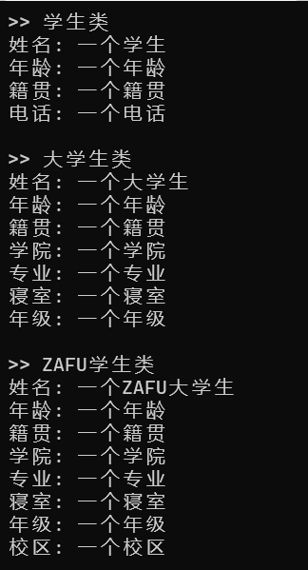
设计一个方凳类RectDesk，它是从矩形类Rectangle和凳子类Desk派生的，要求输出一个方凳的高度、桌面面积和颜色等数据。
分析：Rectangle类包含私有数据成员x,y和求矩形面积的成员函数getarea()；Desk类包含私有数据成员height和返回高度的成员函数getheight()。RectDesk类继承所有上述类的数据成员和成员函数，添加私有数据成员color和相应的成员函数。
#include <iostream>
#include <string>
using namespace std;
class Rectangle {
public:
Rectangle(int _x, int _y) {
x = _x;
y = _y;
}
int GetArea() {
cout << "面积: " << x * y << '\n';
}
private:
int x, y;
};
class Desk {
public:
Desk(int _height) {
height = _height;
}
int GetHeight() {
cout << "高度: " << height << '\n';
}
private:
int height;
};
class RectDesk : public Rectangle, public Desk {
public:
RectDesk(int _x, int _y, int _height, char *_color) : Rectangle(_x, _y), Desk(_height) {
color = _color;
}
void GetColor() {
cout << "颜色: " << color << '\n' << '\n';
}
private:
string color;
};
int main() {
char t1_color[20] = "白色";
RectDesk t1(2, 3, 4, t1_color);
t1.GetArea();
t1.GetHeight();
t1.GetColor();
char t2_color[20] = "灰色";
RectDesk t2(3, 4, 5, t2_color);
t2.GetArea();
t2.GetHeight();
t2.GetColor();
char t3_color[20] = "黑色";
RectDesk t3(4, 5, 6, t3_color);
t3.GetArea();
t3.GetHeight();
t3.GetColor();
return 0;
}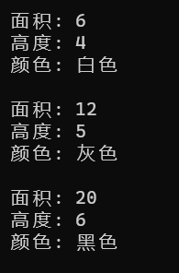
设计一个员工类Worker，包含姓名、年龄。再派生出一个经理类Manager，包含职务和部门私有数据成员以及相关的成员函数。再派生出一个设计师类Designer，包含职称和专业私有数据成员以及相关的成员函数。然后由Manager和Designer类派生出设计部经理类DesManager，包含工资私有数据成员以及相关的成员函数。要求使用虚基类，并在main()中采用一些数据进行测试。
#include <iostream>
#include <string>
using namespace std;
class Worker {
public:
Worker(char *_name, char *_age) {
name = _name;
age = _age;
}
void Disp() {
cout << "姓名: " << name << '\n';
cout << "年龄: " << age << '\n';
}
string name, age;
};
class Manager : virtual public Worker {
public:
Manager(char *_name, char *_age, char *_job, char *_part) : Worker(_name, _age) {
job = _job;
part = _part;
}
void Disp() {
cout << "职务: " << job << '\n';
cout << "部门: " << part << '\n';
}
private:
string job, part;
};
class Designer : virtual public Worker {
public:
Designer(char *_name, char *_age, char *_pos, char *_major) : Worker(_name, _age) {
pos = _pos;
major = _major;
}
void Disp() {
cout << "职称: " << pos << '\n';
cout << "专业: " << major << '\n';
}
private:
string pos, major;
};
class DesManager : public Manager, public Designer {
public:
DesManager(char *_name, char *_age, char *_job, char *_part, char *_pos, char *_major, char *_fare) : Worker(_name, _age), Manager(_name, _age, _job, _part), Designer(_name, _age, _pos, _major) {
fare = _fare;
}
void Disp() {
cout << "工资: " << fare << '\n' << '\n';
}
private:
string fare;
};
int main() {
char t1_name[25] = "一个名字 - Test<1>", t1_age[25] = "一个年龄 - Test<1>", t1_job[25] = "一个职务 - Test<1>", t1_part[25] = "一个部门 - Test<1>", t1_pos[25] = "一个职称 - Test<1>", t1_major[25] = "一个专业 - Test<1>", t1_fare[25] = "一个工资 - Test<1>";
DesManager t1(t1_name, t1_age, t1_job, t1_part, t1_pos, t1_major, t1_fare);
t1.Worker::Disp();
t1.Manager::Disp();
t1.Designer::Disp();
t1.DesManager::Disp();
char t2_name[25] = "一个名字 - Test<2>", t2_age[25] = "一个年龄 - Test<2>", t2_job[25] = "一个职务 - Test<2>", t2_part[25] = "一个部门 - Test<2>", t2_pos[25] = "一个职称 - Test<2>", t2_major[25] = "一个专业 - Test<2>", t2_fare[25] = "一个工资 - Test<2>";
DesManager t2(t2_name, t2_age, t2_job, t2_part, t2_pos, t2_major, t2_fare);
t2.Worker::Disp();
t2.Manager::Disp();
t2.Designer::Disp();
t2.DesManager::Disp();
char t3_name[25] = "一个名字 - Test<3>", t3_age[25] = "一个年龄 - Test<3>", t3_job[25] = "一个职务 - Test<3>", t3_part[25] = "一个部门 - Test<3>", t3_pos[25] = "一个职称 - Test<3>", t3_major[25] = "一个专业 - Test<3>", t3_fare[25] = "一个工资 - Test<3>";
DesManager t3(t3_name, t3_age, t3_job, t3_part, t3_pos, t3_major, t3_fare);
t3.Worker::Disp();
t3.Manager::Disp();
t3.Designer::Disp();
t3.DesManager::Disp();
return 0;
}
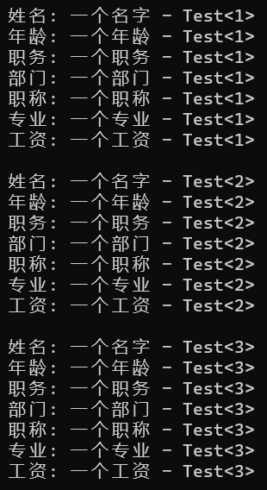
四 实验小结
巩固了C++的继承。

